|  |  |
| --- | --- |
|  | ERRINGTON ELEMENTARY SCHOOL |
| 1390 Fairdowne Road, Errington, BC V0R 1V0  Phone: (250) 248-8446 Fax: (250) 954-1593  Website: http://ees.sd69.bc.ca |
| Principal: Mrs. Sheila Morrison **Email:** [**smorrison@sd69.bc.ca**](mailto:smorrison@sd69.bc.ca) Vice-Principal: Ms. Florence Wong **Email:** [**fwong@sd69.bc.ca**](mailto:fwong@sd69.bc.ca) |

January 6, 2023

**Principal’s Message**

Happy New Year! As we begin a new calendar year, it is a good time to set goals with your children, take stock of your child’s habits, and make needed adjustments.

The following article provides some suggestions on reviewing the first half of the school year:

Talk with your child about how he thinks the school year is going. If the two of you set learning goals at the start of the year, review those goals now. Is he making progress? How can he make the rest of the school year even better?

Then, help your child make some resolutions. Here are four to consider:

1. **Recommit to routines.** Has your child’s bedtime begun to slip? Are mornings more rushed? Is his regular study time now not quite so regular? Sleep and study routines make life easier – and help kids do better in school.
2. **Spend more time reading.** There is no skill that will help your child more in school. And reading ability, like other skills, gets better with practice. Encourage your child to read every day. Let him read about anything, from sports to his favourite movie characters.
3. **Limit recreational screen media.** Talk about ways to reduce the amount of time your child spends watching videos and shows, playing games and browsing online. Set and enforce daily limits.
4. **Have a positive mindset.** Positive thinking makes it easier for students to tackle challenges and ask for help. To promote positivity, help your child manage his stress, visualize a successful outcome and learn from his mistakes.

*Source: Elementary School Parents. January 2022; Vol. 33, No.5*

**Upcoming Non-Instructional Day**

A reminder that we have a short week coming up at the end of January. School is not in session on **Monday, January 30th**. This is the District Wide Planning Day.



Kindergarten registration will start towards the end of January! Please stop by the office or contact us at (250) 248-8446 if you have any questions regarding the upcoming Kindergarten registration requirements.

All new students must register at their catchment area school. Information for those students wishing to attend a school outside their catchment will be available shortly.

If you know of any families who will need to be aware of this information, we ask you to please pass this along to them.

**IMPORTANT INFORMATION FOR GRADE 7 FAMILIES**

We are in the process of planning for the transition of our Grade 7’s from Elementary to Secondary school. Next week, Grade 7 students will be receiving a “transition planning survey”. This will be the beginning stage of the transition process.

**Kwalikum Secondary School** (KSS) has already set a tentative date of **Thursday, February 16th** to host an open house/information evening for students and parents. This in-person session will be from 6:30pm – 7:30pm and will start in the Multi-Purpose Room at KSS.

**Ballenas Secondary School** (BSS) will be setting an open house/information evening date very soon and we will communicate that date to you as soon as we get it.

Both open house sessions will provide students and parents with an opportunity to familiarize themselves with the secondary school programs and other offerings.

KSS and BSS staff will be visiting Errington Elementary School soon to meet with our Grade 7 students, provide them with course selection packages, and answer questions the students may have.

**Learning Updates**

On **Wednesday, February 8th**, your child will receive a “Learning Update” (otherwise known as Report Cards).

Teachers take great pride in their work with students and families. They will continue to connect with you in a variety of ways throughout the year – through class newsletters, student planners and home folders, phone calls, emails, electronic portfolios, informal conversations, and the parent/teacher conference opportunities during the year.

If you haven’t already, we encourage you to establish an ongoing mode of communication with your child’s teacher so that you can understand where your child is at with various aspects of their learning, what challenges he/she is facing, and where to go next with learning.

**Reminders**

* We are required to follow the BC Healthy Food and Beverage Guidelines when serving food in schools. If you are wanting to send treats to school to help celebrate a special occasion, please contact your child’s teacher in advance to make arrangements. Food must be prepared and packaged in a Food Safe Certified facility.
* Please make sure your child has appropriate clothing and footwear for outdoor use, along with a pair of inside shoes and an extra change of clothes. We also recommend having a warm coat, hat, umbrella, and gloves. We have a good supply of clothing and hand-knit items on hand. Please let us know if your child needs any warm clothing.
* When reporting your child’s absence, please call the office at 250-248-8446 (after hours you can leave a message on our answering service – just listen for the option to report a student absence in the directory). It is important to let the office know if your child will be late or not attending school for the day(s) so your child is accounted for. It only takes a minute. If your child is not at school or late you can expect to receive a call to your main number. Thank you in advance for reporting early!
* School begins at 8:10am. If you are dropping off your child prior to 8:10am, please use the Lower Parking Lot. If you are dropping off after 8:10am, you may pull up to the front of the school. Students who arrive after 8:15am must report to the office before going to their classroom.
* Please make sure your child’s teacher is aware of your child’s after school schedule. We need to know if your child is getting picked up (and by who) or taking the bus.

**Student Learning Survey**

The Student Learning Survey is for students in Grades 4, 7, 10, and 12, their parents, and staff.

The survey covers a wide range of topics and provides feedback on the implementation of the curriculum changes, learning environment, student wellness and satisfaction, student belonging and engagement, and career preparation. Questions were developed with input from partner groups, teachers and experts in educational measurement and special education. This survey will be administered to our Grade 4 and 7 students in the coming months. Parents of Grade 4 and 7 students are encouraged to complete this survey by clicking on the link below.

Parents may access the survey following the directions and link for **Direct Access** below. Surveys are to be completed by parents with children in Grades 4, 7, 10, and 12. A parent may complete a survey for each child in the targeted grades. The parent survey is available in English, French and 16 other languages. Thank you in advance for your participation. The survey is open until midnight on **April 29, 2023**.

**To complete the survey:**

1. Go to any computer that has an up-to-date internet browser access. Acceptable browsers include Firefox, Internet Explorer, Chrome or Edge.
2. Go to [www.bced.gov.bc.ca/sat_survey/access.htm](http://www.bced.gov.bc.ca/sat_survey/access.htm)
3. Scroll down to the “Parent” section and select *Direct Access – no logon number required; then* select:
   * District: the name of your child’s school district (69 – Qualicum)
   * School: the name of your child’s school (Errington Elementary)
   * Language: the language of your choice
4. Complete the survey by clicking on the appropriate circle to answer each question. Move to the next set of questions by clicking on the right arrow in the bottom right corner of the screen. Click on the left arrow to navigate backwards.
5. When you are finished the survey, you will get a message “Thank you for sharing your views”.

 **Remembrance Day – Legion Contest**  

Several EES students participated in the local Legion Literary and Poster Contest back in November. We are proud to celebrate and recognize the following students who recently received awards:

Ava from Homeroom 15 – 2nd Place in Primary Colour

Victoria from Homeroom 16 – 2nd Place in Intermediate Colour

Aaleyah from Homeroom 4 – 1st Place in Junior Colour

Anna from Homeroom 5 – 1st Place in Junior Poem

Marley from Homeroom 16 – 1st Place in Intermediate Colour

Students who were awarded 1st Place will have their entries forwarded to the Vancouver Island Regional Contest. Congratulations to all who participated in this contest!

**NEW WAY TO PAY**

**Our district has made it possible to pay for any school fees online. If your student’s classroom teacher has requested to use agendas, a sheet with detailed instructions on how to sign up for School Cash Online has come home. If your student’s teacher is not using agendas this year a detail sheet will come home shortly. On our Errington Website there is a direct link to** [**www.schoolcashonline.com**](http://www.schoolcashonline.com)**, it is quite easy to sign up. Once signed up you will receive email notifications if there is a fee associated with your student. You are still able to pay for any school fees with cash or cheque, but we are offering the option to pay online.**

**As always if you need any help navigating this system please feel free to call the office and they will be happy to help you.**



Munchalunch Hot lunches is **open** and ready for ordering.

January 13 – Ricky’s

January 27 – Pizza

February 10 – Sushi

February 24 – Ricky’s

March 3 – Subway

March 17 - Pizza

***Please note that all lunches close on Munchalunch a week prior to lunch date.***

<https://munchalunch.com/schools/Errington/>

**Use of Technology**

We value the use of technology as an integral part of teaching and learning. Our handheld devices have become part of our daily routines and give us access to a wide variety of tools, including photographing our students doing all sorts of activities at school. We have noticed that some photos of our students have appeared on social media – we understand that people taking and sharing photos during school sanctioned activities are doing so with good intentions. What people may not realize is that we have a number of students who have media restrictions in place and parents have indicated they do not want their child’s photo to appear publicly. In order to respect the privacy of our students, we ask that you do NOT download, copy, or distribute any pictures or other personal information through social media that contain images of students and/or student work other than your child’s.

**School District 69 is hiring school bus drivers**.

Come help us deliver the future!

Minimum Class 2 License with Air Endorsement Required.

For more information got to [www.sd69.bc.ca](http://www.sd69.bc.ca)

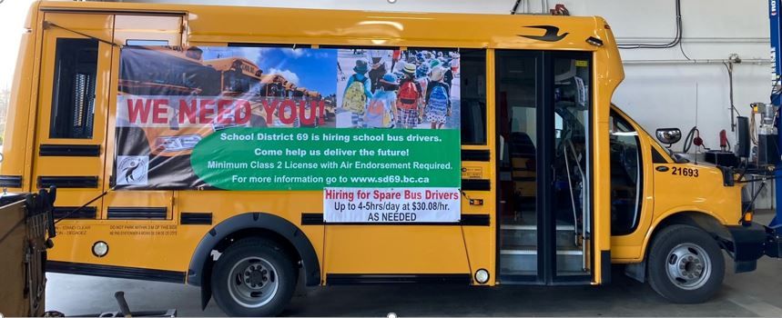

**EES LIBRARY NEWS**

Happy New Year from your Library Learning Commons!

This month under the Moon of The Shining Ice, we're featuring many wonderful books about the moon, winter season, weaving and storytelling.  Come and check them out!

**Seriously Awesome Series Book Draw:**   Our Senior Library Pages will be visiting classes next week to talk about our Seriously Awesome Series Book Draw which begins January 16 and runs until spring break. Students are encouraged to take out a book belonging to a series, read it, then bring it back with an entry form to the Book Draw. Good luck!

**DEAR - Wed January 18 is Drop Everything and Read Day** to celebrate School Library Day. Students and staff are invited to drop what they're doing, grab a great book and read from 11:05-11:35 a.m. You can join in at home, too!  Ask us about some great books you'll love to drop everything for!

**Leadership Lunch:** On **Wed January 25**, we'll be inviting Term 1 Leaders to drive thru the Library and pick up their pizza lunch. This is our way to thank our wonderful leadership students for all they do every day in our school!

**Gladiators Chess Club:**  Students who love to play chess, or would like to learn, can come down and sign up for our Gladiators Chess Club. We'll be playing chess every Thursday at lunch in the library. The EES tournament will begin in February for those Grade 4 to 7 students who would like to compete. More information about the District Chess Tournament to follow.

**Lost Books:**  If you have lost a book, 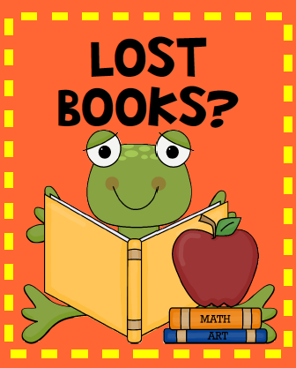you can replace it with a similar book from home. Please look for overdue books and return them to the Library.

**Your Library Card:** Did you know that your family members can take books out on your student library card?  Ask us about bringing great books home for the whole family.

Ms. Richards and Mrs. Cook



**Community Programs**

We get numerous advertisements for community programs and opportunities to include in newsletters. Rather than inserting the whole advertisement in our newsletters, we will now provide the links below for you to click to view:

**Other Community Events & Programs 2021**

Please click on the PDF link below to view the events/programs offered – access is via the SD69 Community Page:

**SOS Winter-Spring 2023 Program Guide**

**Invitation to submit rock painting – Parksville Visitor Centre**

<https://www.sd69.bc.ca/Community69/Pages/default.aspx#/>

**Information for Families:**

**Family Accident Reimbursement Plan**

**2022-2023 Board SD69 Public Meetings of the Board of Education**

<https://www.sd69.bc.ca/Parent/Pages/default.aspx#/>

|  |
| --- |
| **EES Calendar of Events** |

|  |  |  |
| --- | --- | --- |
| EES Calendar of Events | | |
| January | 30 | District Wide Planning Day – No School |
| February | 14 | Career Fair for Grade 7 Students |
|  | 16 | KSS Open House/Information Evening for Grade 7 Students and Parents (see info in this newsletter) |
|  | 17 | Professional Development Day – No School |
|  | 20 | BC FAMILY DAY – No School |
| March | 17 | Last day of school before Spring Break |
| April | 3 | School Re-opens after Spring Break |
|  | 7 | GOOD FRIDAY – No School |
|  | 10 | EASTER MONDAY – No School |
|  | 19 | Scholastic Book Fair (In the library) – runs until Apr.25 |
| May | 18 | Professional Development Day – No School |
|  | 19 | Conferencing Adjustment Day – No School |
|  | 22 | VICTORIA DAY – No School |
| June | 29 | Last day of school, ends 3 hours early |
|  |  |  |