October Newsletter, 2018
False Bay School

Upcoming Events

PAC Meeting
The PAC meeting will take place on Wednesday October 10 at 3:30. Please plan on attending to vote in this year’s budget.
Reading Groups
Our reading-mentor program will be happening Oct.16-Nov 21 on Tuesday and Wednesday mornings, 9:15-9:45. If you know of someone who would enjoy being paired up with a group of kids, please ask them to call the office or let Kirsty know your suggestions.
Speech and Language
Andrea Coombes, the Speech and Language Pathologist for the district will be visiting FBS on Thursday October 11 to meet with the kids.
Parent-Teacher Conferencing
Please sign up at the office for conferencing with Kimi and Anna, Oct 15,16,17, 3:30-6:30.

Cross-County Track and Field Meet
The SD69 Track and Field Meet is taking place on Friday October 26 at Springwood Elementary at 10am. It is open to grades 3-7. If you think your kids would like to participate in this event please talk to Kirsty for more details.

raPeewees: Grades 5/6: 2.0km (Girls race at 10:30, Boys race at 10:45)
Bantams: Grade 7: 2.5km (Girls race at 11:00, Boys race at 11:15)

250-333-8813
Office Hours: 8:30-1:30 (2:30 on Altered Fridays)
Notes From Our Vice Principal Lesley LaCouvée…
Fall is upon us….
We had a wonderful start to our 2018 – 2019 school year. So far the students have engaged in a variety of exciting, rich, robust learning experiences and are settling in nicely to their school routine. To support our school goal of “communicating student learning in authentic, meaningful ways using a variety of modalities”, coupled with the BC Ministry’s new Reporting Order, you can expect some changes in reporting,
The new reporting order asks teachers to provide four Points of Progress during the school, culminating in a Summary of Progress. These Points of Progress include, Term report cards, digital and paper portfolios, interim reports, parent teacher interviews, email, telephone conferences to name a few. The 4 Points of Progress communicate learning in the following ways by;
- recording progress in each area of learning in relation to the redesigned curriculum
- using the standard four- point provincial proficiency scale
- providing written descriptive feedback
- recording student engagement and behaviour
- including student- selected evidence of and reflection on Core Competency development
The Summary of Progress communicates learning in the following ways;
- providing a written report at the end of year
- using strength based language
- providing descriptive feedback and next steps for learning
- providing the four – point provincial proficiency scale descriptor for each area of learning
- recording student engagement and behaviour
cntd...
- including student- selected evidence of and reflection on the Core Competency development
We will be using the following four point provincial proficiency scale;
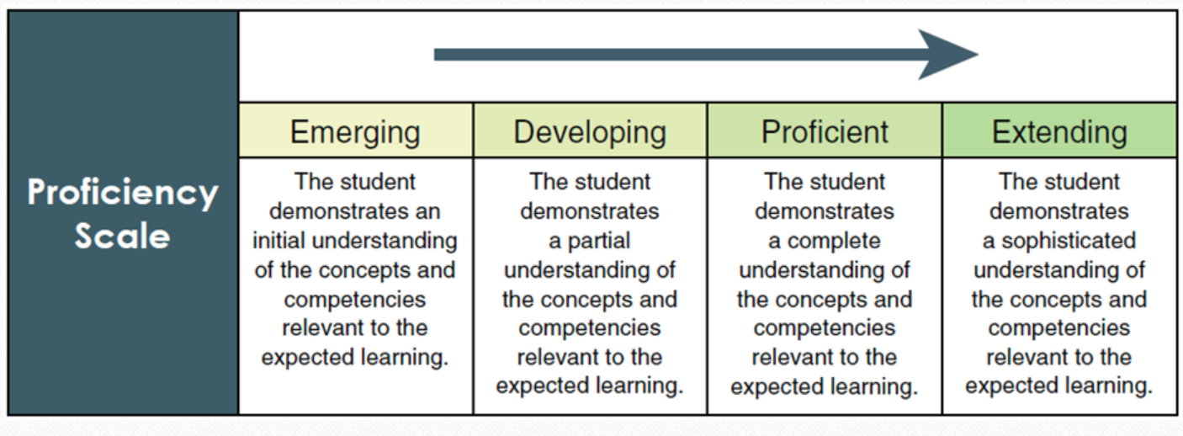
We look forward to communicating student learning to parents throughout the school. If you have questions, please do not hesitate to contact me.
Thank you,
Lesley LaCouvee
Hot Lunch
Our Hot Lunch Program is rolling along. To schedule your day to cook call Julia (228-2284.) Robin is in charge of food-ordering so let her know what you need the week before your shift. (8520)
Otherside Opportunities:
Kids in grade 5 are eligible for an Active Living Card. This gets them free skating, swimming and drop-in Gym anywhere in Nanaimo or Parksville for the year! Just go to the desk at Ravensong Aquatic Centre or Oceanside Place Arena to fill out a simple form.
Grade 6 kids get a pass for 10 free admissions.
Free Skating with rentals at Oceanside Place on Sunday 12:14-1:45 starting October 14!
No School On These Days
Friday October 5: Altered Friday
Monday October 8: Thanksgiving
Thursday October 18 and Friday October 19:Non-Instructional Days
Friday October 26: Altered Friday

