**School District 69 (Qualicum)**

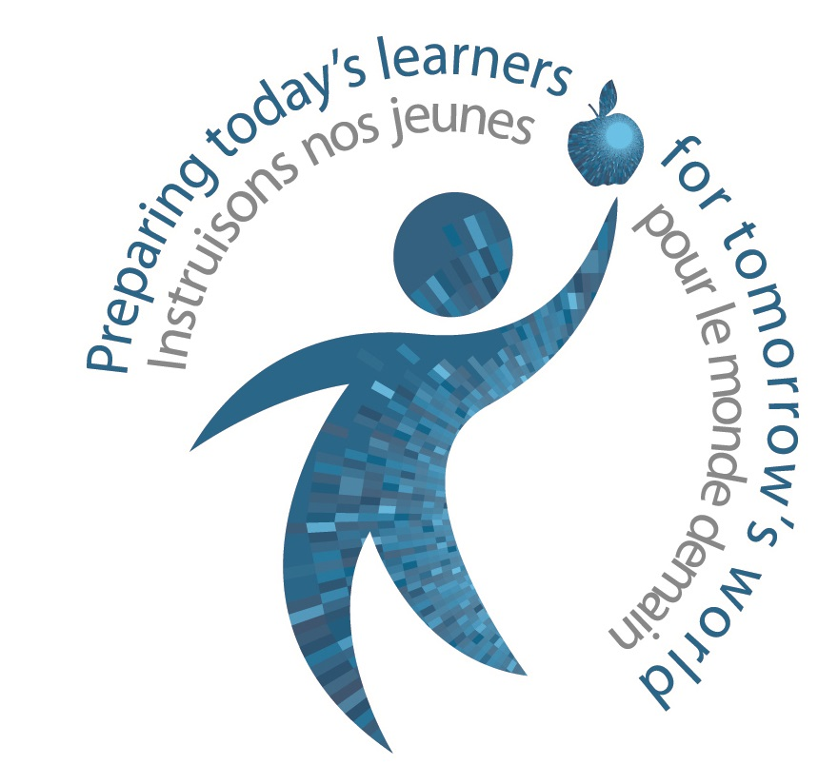

PO Box 430

Parksville, BC V9P 2G5

Phone: 250-248-4241

Fax: 250-248-5767

www.sd69.bc.ca

**Helpful Links:**

BC Kindergarten Curriculum: <https://curriculum.gov.bc.ca/>

BC’s Primary Program:<https://www2.gov.bc.ca/assets/gov/education/early-learning/teach/resources/primary_prog.pdf>

Qualicum School District: [www.sd69.bc.ca](http://www.sd69.bc.ca)

Oceanside Building Learning Together (OBLT):

<https://www.oblt.ca/>

Let’s Play! Activities for Families

<https://www2.gov.bc.ca/gov/content/education-training/early-learning/support/play#letsplay>

Early Learning Framework

<https://www2.gov.bc.ca/assets/gov/education/early-learning/teach/earlylearning/elf-a-guide-for-families.pdf>

Helping Your Kindergartener with Separation Anxiety

<https://www.youtube.com/watch?reload=9&v=r_5eiYIo1XM>





****Do children have to go to kindergarten?****

* Children are entitled to an education program in the school year in which they turn 5 years old before December 31st.  Most children in British Columbia are registered for Kindergarten.  Parents must enroll children or home school them in the school year in which they turn six.  If parents choose to delay enrolment for their 5-year-old until the following year, they should discuss with the school principal the best placement for their child.

**If my child is registered in Kindergarten, can they attend less than full-time?**

* According to the *School Act*, school attendance is not mandatory for 5 year-olds. Therefore, even though you may have registered your child in a Kindergarten program, it is not mandatory that they attend Kindergarten all day, every day.

We hope you will work together with the school administrators and the Kindergarten teacher to determine what is best for your child.

**What are some community programs I can go to with my child?**

* Vancouver Island Libraries
* Munchkinland in partnership with StrongStart
* Mother Goose Goes to School
* RDN Programs
* SOURCES Programs
* SOS Programs

# Welcome to Kindergarten!

**Working Together for Children**

When your child enters school, we hope you will enter too! We invite you to become involved in class and school activities. Please talk with your child’s teacher to discuss your child’s needs and how to access services which your child may need. Your interaction and involvement is vital to your child’s success.

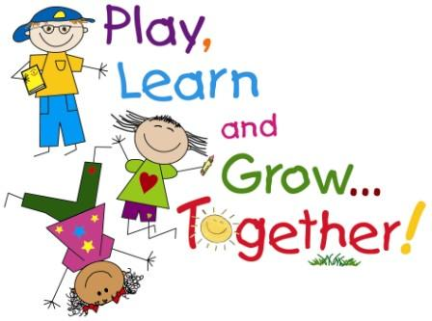

#### Frequently Asked Questions

Kindergarten children are:

* Energetic
* Lively
* Sensitive
* Wonderful
* Curious
* Creative
* Playful
* Uniquely individual

# How to Prepare Your Child for Their First Day

Families are a child’s first and most important teachers. You have already helped your child learn.

Entering the school system for the first time is a big step in your child’s life as well as in yours. Your child’s feeling of excitement about the new experience may conflict with the fear of leaving you for an unfamiliar place.

You can help alleviate this concern by providing opportunities for your child to play with their friends or attending group activities. This practice in play allows your child to experience some separation from you.

Continue to play, read and talk to your child.

**You Can Make the Most of Your Child’s Kindergarten Experience By:**

* helping your child have regular, prompt school attendance
* seeing that your child gets enough sleep and a healthy meal before school
* managing their amount and type of screen time
* sharing information with the teacher about any situations that affect your child’s learning or well-being
* alerting the teacher to any concerns you or your child may have as they arise
* sharing any information about early interventions your child has benefited from prior to Kindergarten (e.g. speech and language, physiotherapy)
* following up with the home activities suggested by the teacher
* reminding your child of thoughtful manners and health habits (e.g. washing hands, using the washroom)

#### Welcome to Kindergarten!

# Gradual Entry

Children start attending school in September in small groups to ensure a successful and comfortable beginning to school. This practice is supported by the Ministry of Education and Child Care and the Qualicum School District.

Please check with your local school for details about gradual entry procedures and times.

**What Does Learning Look Like in Kindergarten?**

Kindergarten is a play-based and designed to address all areas of child development: physical, social, emotional, artistic, language, and cognitive.

# [See full size image](http://www.owen.kyschools.us/trt/primay%20websites/bd05090_.gif)

**Importance of Play**

Research has shown that play:

* enhances a child’s language development
* encourages social development, creativity and problem-solving
* provides opportunities for children to represent their thinking
* acts as a basis for learning in literacy, numeracy and other curricular areas
* develops higher motivation to learn, and promotes higher self-esteem
* nourishes natural curiosity and supports overall healthy development

# Ways Your Child Will Learn

Kindergarten is an active environment in which children learn with their whole bodies, their minds, and their hearts.

In Kindergarten classrooms you will see children learning:

* through physical movement, music, and art activities
* through hands-on activities
* to make thoughtful choices
* to accept responsibility for their actions
* to be comfortable and confident and cooperate in a larger social group
* to accept and respect others
* to think and talk about their learning
* by talking and playing with materials and each other
* by using literacy and mathematics skills throughout the day
* by experimenting with print in a variety of playful ways
* by having fun!