LOCAL FOOD BANKS
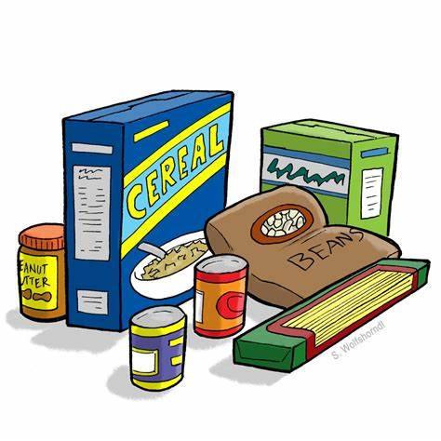

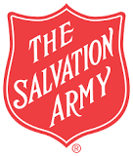
Mt. Arrowsmith Salvation Army Food Bank – 250-248-8794 – 866 Wembley Rd, French Creek - By appointment
Parksville Soup Kitchen – 250-954-0707- Mt. Arrowsmith Salvation Army Community Church, 187 Alberni Highway, Parksville. Take out meals only at this time (2020) Monday, Tuesday, Wednesday and Fridays from 11 a.m. to 1 pm..

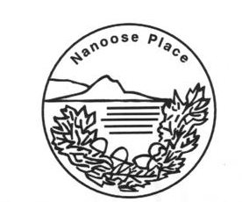

Nanoose Bay Community Cupboard – 250-468-9888 – Nanoose Place Community Centre, By Appointment

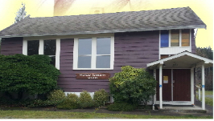
Kiwanis Lighthouse Community Cupboard – 250-757-8148 - Wildwood Church, 113 McColl St., Bowser, By Appointment

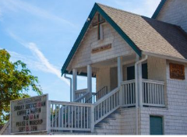
Grace Community Cupboard – 250-248-8793, Grace United Church, 2304 Alberni Hwy, Coombs

