
Qualicum School District 69
District Parent Advisory Council
AGENDA - General Meeting
Date: Wednesday, November 14, 2023 (Every month on the 3rd Wednesday)
Time: 6:30PM
Location/Zoom: https://us02web.zoom.us/j/86524034006?pwd=bm9sdnlmSXc1bHJsYjBweVA3UGtPQT09
Meeting ID: 865 2403 4006 Passcode: 365257

Meeting Purpose:
- Engage, empower and support parents/guardians for the success of all learners
- Support, encourage and improve the quality of education and well being of students by being a district voice
- Build relationships, share knowledge and create community
- Public meeting for all parents/guardians with student(s) in SD69
Attendees/Invitees:
- SD69 DPAC Executive Team
- SD69 School PAC Executives/Representatives:
CEAP - Collaborative Educational Alternative PASS
AES - Arrowview Elementary School BES - Bowser Elementary School
EOES - Ecole Oceanside Elementary School EES - Errington Elementary School
FBS - False Bay Elementary School NBES - Nanoose Bay Elementary School
QBES - Qualicum Beach Elementary School SES - Springwood Elementary School
BSS - Ecole Ballenas Secondary School KSS - Kwalikum Secondary School
- SD69 DPAC Committee Members (formed by DPAC President)
- SD69 Representatives: School Year 2023/24
  - Superintendent of Schools: Peter Jory
  - Associate Superintendent of Schools: Gillian Wilson
  - Director of Instruction: Rudy Terpstra
  - Trustee(s): Julie Austin, Eve Flynn, Carol Kellogg, Barry Kurland, R. Elaine Young
  - MATA President: Matt Woods
  - CUPE Local 3570 President: Sherrie Brown
  - SD69 Parents/Guardians
  - Guests as requested & required (at the discretion of DPAC President)

2023/2024 DPAC Executive Team:

Karri Kitazaki: President Amanda Hastings: Director
Jessica Threlfall: Vice President Michael Kilburn: Director
Brenda Fischer: Treasurer Andrea Button: Director
Angel Delange: Secretary
Angel Delange: Past President
N/A 2023/24: Director - FAC/French Advisory Council *EOES & BSS have FAC Reps
TBD 2023/24: District Associate to BCCPAC * to be reviewed 2023/24

AGENDA

- Call to Order: Time
- Welcome / Traditional Territories Acknowledgment:
We would like to acknowledge that Qualicum School District exists within the territories of the Coast Salish People and within the shared traditional territories of the Qualicum and Snaw-Naw-As (Nanoose) First Nations.
- Introductions & Quorum Declaration: Quorum: 3 voting members
- Approval of Agenda: Changes, additions, approval
- Approval of Previous Minutes: Errors, omissions, adoption
- SD69 Updates: Report, update, questions
  - Superintendent/Associate Superintendent of Schools
  - Director of Instruction
  - Trustee
  - MATA
  - CUPE
- Reports: Report, update, discuss, recommendations, questions
  - President/Vice President: (Karri/Jessica)
    - THANKS for the Parent Information Session
    - THANKS for coffee with DPAC
  - Treasurer Update: (Brenda)
    - Nov 14th DPAC Account Summary (Statements have not been received in the mail yet)
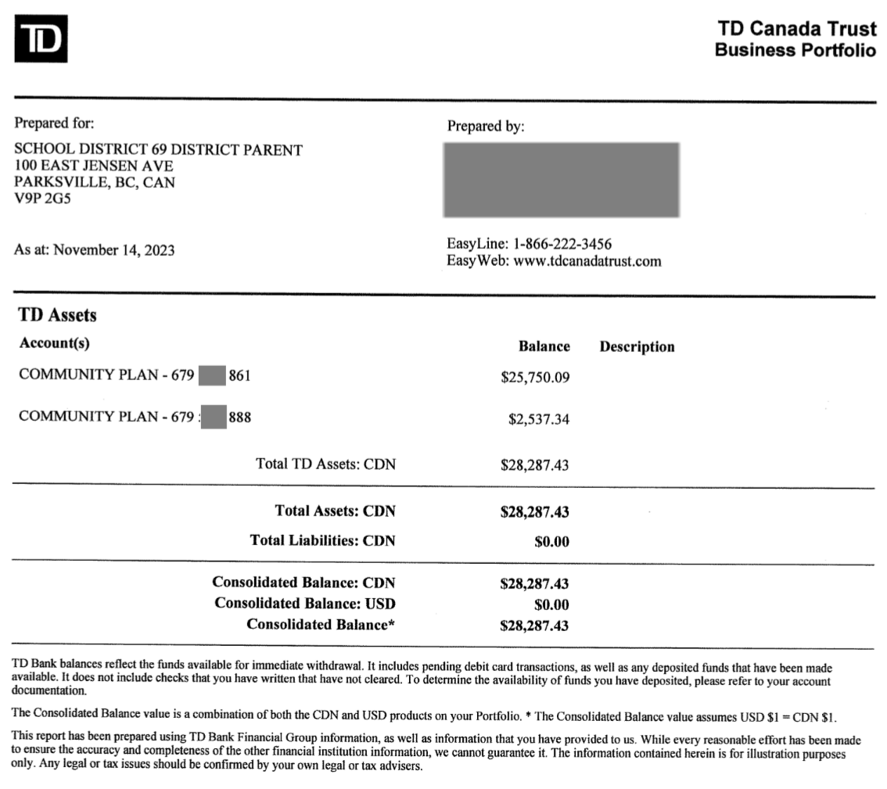
  - Committees: Ad-hoc (specific task/objective, dissolved after completion)
    - Accessible Bikes - (Jessica)
  - Committees: Standing (specific task/objective, ongoing & continued existence)
    - FAC - French Advisory Committee: Next Meeting: Nov 27(Angel/TBD)
    - School PAC Updates/Roundtable: (Highlights Presented by School PAC Rep)
      - CEAP - Collaborative Educational Alternative
      - PASS
      - AES - Arrowview Elementary School
      - BES - Bowser Elementary School
      - EOES - Ecole Oceanside Elementary School
      - EES - Errington Elementary School
      - FBS - False Bay Elementary School
      - NBES - Nanoose Bay Elementary School
      - QBES - Qualicum Beach Elementary School
      - SES - Springwood Elementary School
      - BSS - Ecole Ballenas Secondary School
      - KSS - Kwalikum Secondary School
- Unfinished Business: Items carried forward from last meeting
  - School PAC Constitution Review: (Angel & Karri)
  - DPAC Constitution Review (Karri)
- New Business: Items requiring a discussion, recommendation, decision
  - 2023/24 DPAC Elections - DPAC Director nomination received & acclaimed for Andrea Button. (Karri)
  - DPAC Learning Opportunity Inquiry November 2023 (Angel)
  - Cancel December's DPAC Meeting? (Karri)
- Open Discussion: Questions, concerns or comments
- Next Meeting: December 20th, 2023 OR January 17th, 2024 at 6:30 via Zoom
- Motion to Adjourn: Time

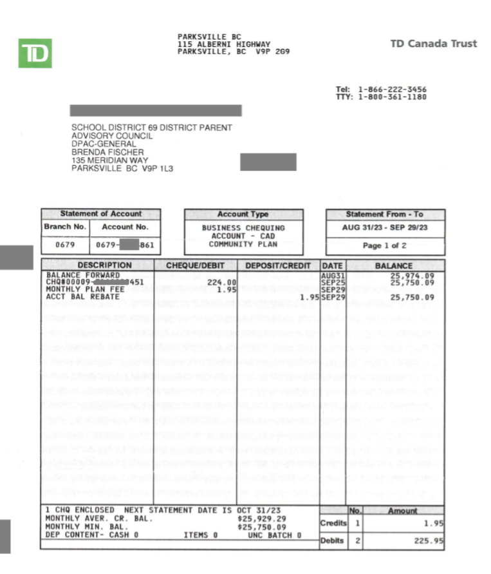
Report Reference:

