Anxiety Group
Supporting Children ages 8-10 struggling with anxiety
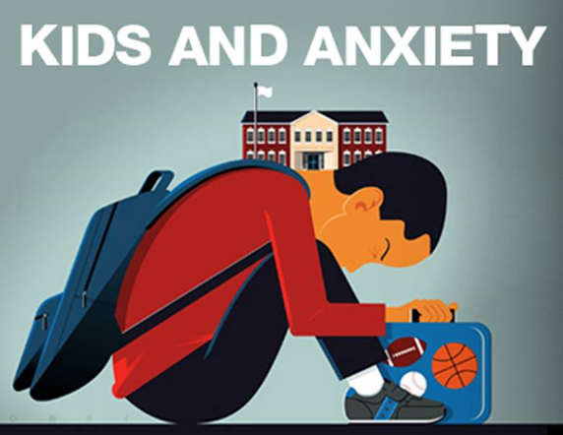
CHILDREN WILL ENGAGE IN A SAFE ENVIRONMENT TO:
- Explore anxiety and understand anxiety in the body
- Learn coping strategies to manage anxiety through a variety of activities
Thursdays, October 12 – November 9, after school 3:30 - 4:30 pm
Family Place (494 Bay Avenue, Parksville)

For registration please email Rachel.Longmore@gov.bc.ca

