Newsletter: February 2019
False Bay School
Reminders:
•All kids need indoor shoes!! Please send a pair in with your child.
•If you have money owing for the hot lunch program, call the office to make arrangements before Spring Break.
•Please return your kid’s signed report card envelopes.
•PAC meeting, Wed. March 13 at 2pm in the kitchen. Will need to elect a new Vice-President to replace Verlee. The meeting will be preceded by a Hot lunch meeting at 1pm.

**************************************
No School This Month on these dates:
Altered Fridays: Feb. 8 and 15
BC Family Day: Mon. Feb. 18
PD Day: Tues. Feb 19(5-Day Weekend!)

250-333-8813
Office Hours: 8:30-1:30 (2:30 on Altered Fridays)
VP email: llacouvee@sd69.bc.ca
Welcome Adrian!!
Dear Parents;
We are very excited to confirm that Adrian Esau will be our new Primary Teacher for False Bay School. Adrian’s first official day will be Monday, April 1st where he will work with our Kindergarten to Grade 3 class. He will also work with our Grade 4- 7 classes during our whole school activities. Adrian hails from Vancouver Island University where he completed his teaching certificate. We are very much looking forward to having Adrian’s calm, relaxed, caring personality join our False Bay team. He will a fantastic addition!
Adrian will be at False Bay on Monday March 11, from 11:00- 3:00pm. He will be meeting with all the students during lunch recess and then having pizza with the kids during the eating period. At 2:30pm, we would like to invite all parents to the school, to formally meet Adrian, and pose any questions you may have to Adrian or Lesley.
As we celebrate our new acquisition, Adrian, we must also recognize and celebrate Kimi. We are so grateful to have had such a wonderful primary teacher at False Bay School; caring, hard – working and a consummate professional. We wish Kimi and her family all the best as she enters into the amazing world of motherhood. Thank you for your contributions, and we look forward to meeting the newest addition to the False Bay School team.

Thank you,
Lesley LaCouvee

llacouvee@sd69.bc.ca

Literacy Grant

In the Community
Lions Club Free-Skate
Every Sunday in Parksville 12:15-1:45. Rentals are included.
Family Day, Monday Feb. 19
- Mount Washington Lift Tickets are 50%-off
- Free Swimming at Ravensong: 10-2
- Free Skating at Oceanside: 1-4.
•Check the bulletin board for Spring Break camps, programs and events.
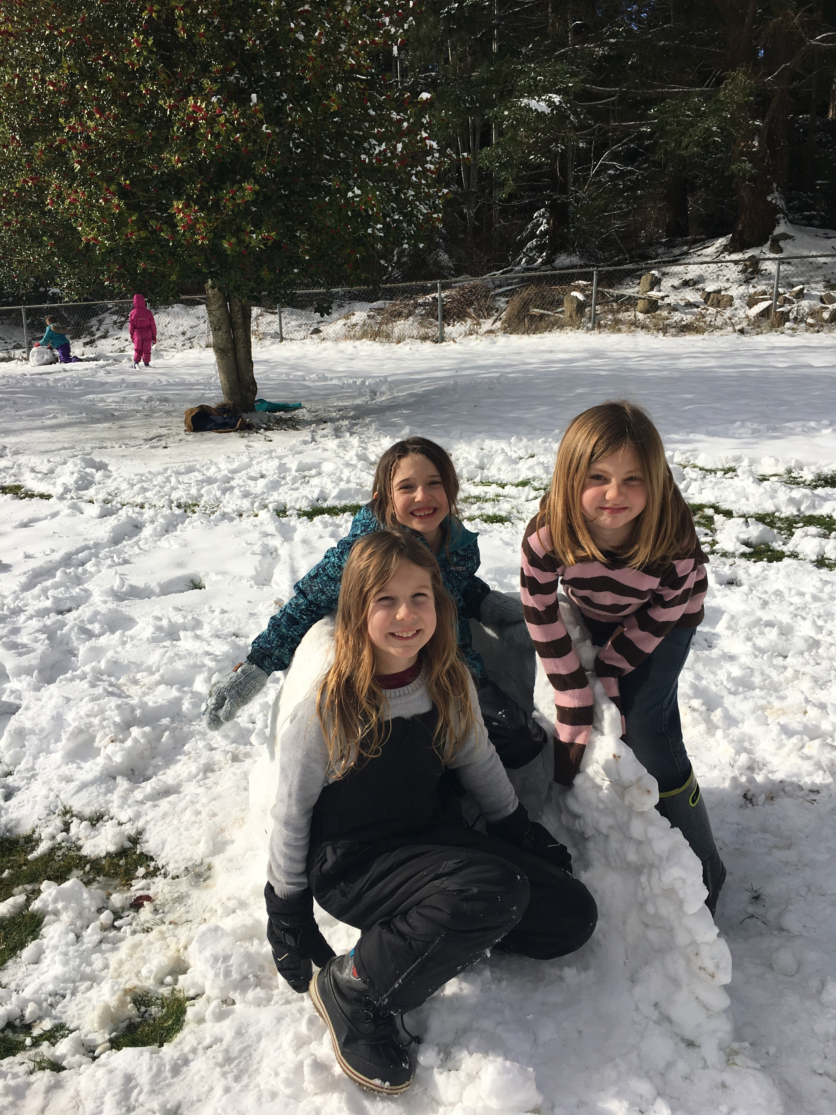

Please be sure to WE LOVE BOOKS!
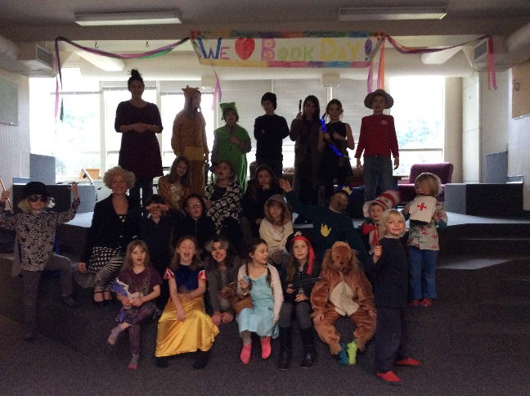
January Field Trip
The school field trip to Flipside gymnastics and the Whalebone Theatre was a smooth success. Thank you to the parents who chaperoned, the kids for being fun, well-behaved travelers and to the wind for finally cooperating!
Virtual Reality
Mark your calendars, Jen Lunny will be coming over on March 7 to take the kids on another virtual reality expedition.

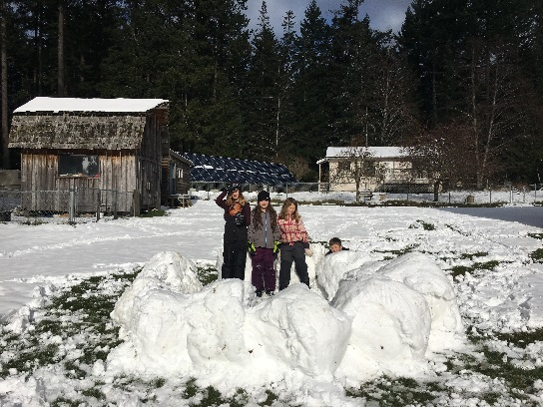
February Days Off
Altered Fridays: Feb 8 and 15
BC Family Day: Monday Feb. 18
PD Day: Tuesday Feb. 19

