September Newsletter, 2018
False Bay School

Upcoming Events

PAC Meeting
The first PAC meeting of the year will take place at 3:30 on Wednesday September 12. The first meeting is one of the most important of the year. The yearly budget will be planned and the executive voted in. Everyone welcome! Please plan to attend!
Meet and Greet
Parents are invited to the school on Thursday September 13 at 2pm to meet the teachers and our VP Lesley LaCouvée. Refreshments will be served.
Field Trip
The Intermediate Class will be heading down to Victoria on October 4-5 to visit the museum, the bug zoo and see the Cirque de Soleil show Corteo!
Weekly Walks
The kids will be going for a walk every Friday at 10am. Parents are welcome to come along.
Library Day
Tuesday is Library Day. Please send back any checked-out books.
Reading Assessments
Carrie Frampton will be coming over on Sept 27.

250-333-8813
Office Hours: 8:30-1:30 (2:30 on Altered Fridays)
Notes From Our Vice Principal Lesley LaCouvée…
Welcome Back!
Fall is my favorite season. I love the crispness in the air, the changing colours, but mostly because it feels like new beginnings! Hopefully, you have returned to False Bay School with the same sense of newness as you entered the freshly painted school, bathrooms, Kimi’s room and coatroom. You may have also noticed the new furniture, the new bathroom cabinetry, new classroom mats and the redesigned office waiting room. As well, we are waiting for new blinds for the two classrooms, centering room and kitchen.
In addition, we are happy to welcome seven new students to our school, which now puts our total enrolment to 29 students from Kindergarten to Grade 8. We are excited to announce that we have secured two additional Teachers on Call (TOCs) that will be available to our teachers for coverage.
What is not new, but equally wonderful, is our staff; Kirsty continues to be our Secretary, Anna continues in her second year working with the elementary students Grades 4- 7, Kimi, is entering her 6th year as the primary teacher of the Kindergarten - Grade 3 cohort. Gordon and Mike will continue their solid work as our Custodian/Operations and Maintenance, and bus driver, I will continue on, as not only the administrator, but a staunch supporter of all things False Bay School.
Building on last year’s goals, we are endeavoring to;
- Communicate Student Learning in authentic, meaningful ways using a variety of modalities and
- Transitioning Students between the grades, new learning environments, and building relationships with outside schools friends
With being said, I would like to wish you all a very “Happy New Year”; let the celebration of learning begin.
Lesley LaCouvee
Vice Principal
False Bay School

The Garden
The False Bay School Yum Garden survived the hot summer beautifully with the sprinklers on a timer! Thank you to PAC, Robin and Julia, Anna, Kathie G and all the others who kept an eye on things over the summer. Anna has created a buddy system between the two classrooms that has the kids working on the garden together. The older class will be cooking Potato Leek Soup in the next few weeks for the whole-school meal, using everything fresh from the garden.
Hot Lunch
Our Hot Lunch Program will be starting up on Tuesday September 11. Lunches are served every Tuesday, Wednesday and Thursday. Please check your kids’ backpack for the mailer. For more information, call Robin(8520), Julia(228-2284) or Kirsty in the office.(8813)
Monthly Hot Lunch Fees.
Kindergarten: $25
Gr.1-3: $30
Gr. 4 and up: $35
Staff: $40
Drop In: $5 per meal
Pay at the office with cash or cheques made out to False Bay School.

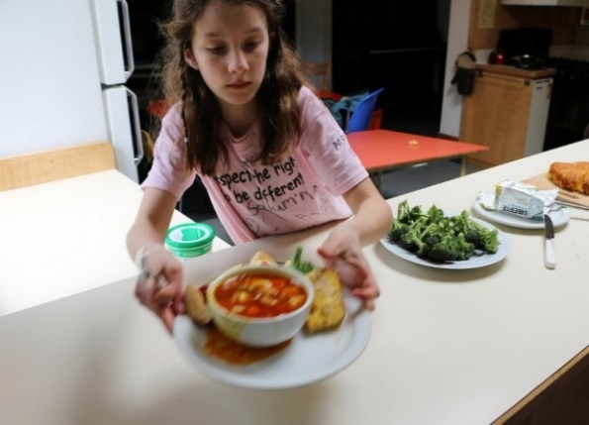
Reminders:
- Please put together a bag of spare clothes, labelled with their names to send in with your child in case they get wet. All kids need a pair of indoor-shoes or slippers.
- Make sure they are dressed in comfort for the weather of the day.
- Any after-school plans must be noted by an adult on the bus notes clipboard. Call Kirsty to relay any messages.
- If you plan to cook lunch or volunteer in the school, come by the office to complete your Police Information Check. Bring photo ID.
- There are always a lot of things to sign at the beginning of the year. Thank you for doing this promptly. Try to have fun with it, experiment with different handwriting styles, etc.
Otherside Opportunities:
Kids in grade 5 are eligible for an Active Living Card. This gets them free skating, swimming and drop-in Gym anywhere in Nanaimo or Parksville for the year! Just go to the desk at Ravensong Aquatic Centre or Oceanside Place Arena to fill out a simple form.
Grade 6 kids get a pass for 10 free admissions.

