|  |
| --- |
|  |
| Newsletter: March 2019 |
|  |

False Bay School

|  |
| --- |
|  |
| **Reminders:**  •**All kids need indoor shoes**!! Please send a pair in with your child.  •If you have money owing for the hot lunch program, call the office to make arrangements to square- up before Spring Break.  • If you haven’t yet done so, please return your kid’s signed report card envelopes.  •PAC Meeting, Wed. March 13 at 2pm in the kitchen. Will need to elect a new Vice-President to replace Verlee. This meeting will be preceded by a Hot lunch meeting at 1pm. Please plan to attend.  **************************************  No School This Month on these dates:  **Altered Fridays**: Feb. 8 and 15  **BC Family Day:** Mon. Feb. 18  **PD Day:** Tues. Feb 19(5-Day Weekend!) | |

250-333-8813

Office Hours: 8:30-1:30 (2:30 on Altered Fridays)

VP email: llacouvee@sd69.bc.ca

**Welcome Adrian!!**

Dear Parents;

We are very excited to confirm that Adrian Esau will be our new Primary Teacher for False Bay School. Adrian’s first official day will be Monday, April 1st where he will work with our Kindergarten to Grade 3 class. He will also work with our Grade 4- 7 classes during our whole school activities. Adrian hails from Vancouver Island University where he completed his teaching certificate. We are very much looking forward to having Adrian’s calm, relaxed, caring personality join our False Bay team. He will a fantastic addition!

Adrian will be at False Bay on Monday March 11, from 11:00- 3:00pm. He will be meeting with all the students during lunch recess and then having pizza with the kids during the eating period. At 2:30pm, we would like to invite all parents to the school, to formally meet Adrian, and pose any questions you may have to Adrian or Lesley.

As we celebrate our new acquisition, Adrian, we must also recognize and celebrate Kimi. We are so grateful to have had such a wonderful primary teacher at False Bay School; caring, hard – working and a consummate professional. We wish Kimi and her family all the best as she enters into the amazing world of motherhood. Thank you for your contributions, and we look forward to meeting the newest addition to the False Bay School team.

Thank you,

Lesley LaCouvee

llacouvee@sd69.bc.ca

|  |
| --- |
|  |
| In the Community **Lions Club Free-Skate**  Every Sunday in Parksville 12:15-1:45. Rentals are included.  **Wednesday Night Social**  Taco night at the hall this Wednesday March 6 at 6:30 to raise funds for the Wet’suwet’en camp.  **Grub and Groove**  Saturday March 9 at the hall. 6pm.  **Spring Break Camps**  Check the bulletin board for the pamphlet of RDN Spring Break activities for your kids to take part in if you go to town. |

**Literacy Grant**

We will be book shopping this month to use the $800 Times Colonist Literacy Grant. Please add your book suggestions to the lists on the bulletin boards.

**Virtual Reality**

Jen Lunny will be coming over on Thursday March 7 to take the kids on another virtual reality expedition. FBS was the first school in the district to try out the goggles and the kids loved it!!

**Ukeleles**

On Tuesdays and Thursdays the kids have been learning to play the Ukelele. There is a sign-out sheet going home for parents to sign if they give their kids permission to bring the instrument home for practicing.

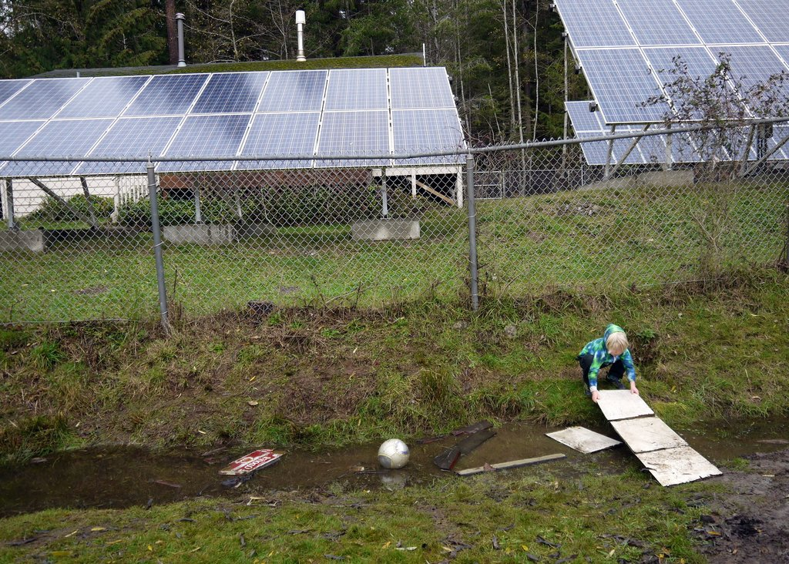

**Spring Break**

**March 18- March 29**

Have a fun holiday everyone! See you back at school on April 1.

The little engineers thank you for sending in spare clothes!