2024 Volleyball Tournament
Location: Oceanside Elementary School- Gym & MPR
Date & Time:
Boys Tournament: March 12: 8:00 AM- 4:00 PM
Girls Tournament Part 1: March: 13: 8:00 AM - 4:00 PM
Location: Springwood Elementary School-Gym and MPR
Date & Time:
Girls Tournament Part 2: March: 14: 8:00 AM- 4:00 PM

Welcome to our 2024 season Volleyball Tournament! We are excited to show off our player's skills! This year's tournament will be held in Oceanside/Springwood gym, with a student break room in the MPR during the school day, both locations have Afterschool Care. The tournament is set in 30-minute blocks allocated for each game, and we will be doing our best to stay on time. As such, we are asking upcoming playing teams to be ready to go and warm up 5-10 minutes before their match. We will be doing a double elimination style tournament, which ensures a minimum of 2 games per team, and more if they continue to win.

Game Play and Rules:
Please review the rules document sent at the beginning of the term. There has been some discrepancy in serving and point allocation. An individual server is able to win up to three (3) points from serves made, after this the ball will change possession. If the other team looses the point, the ball will return and the prior team will rotate. There is no limit to the number of points won through the exchange. I.e. Team A serves, misses the point. Serve switches sides. Team B makes three serves, all winning points. Serve switches sides. Team A serves and misses. This would mean that Team B receives 5 points in a row. This is allowed.

Referee & Score Keeping:
Each court will need 1 coach in the position of ‘Referee’, we will be doing our best to have student scorekeepers. I am waiting upon the contact of gr 12 students, for help. It seems many coaches are comfortable with reffing their own matches, we may need your help with this.

Games are played to 25 points, with a 2 point lead. Games will end at 35 points regardless of 2 point difference to ensure timeliness.

Visitors:
Unfortunately, due to the gym's capacity and the courts' layout, visitor viewing will be limited. We are asking during the games that teams not actively playing wait in the MPR. Visitors can find standing room around the court however they are not to be on the BACK Service line, or mixed into the benches/player area.

Student Expectations:
Students are expected to maintain respectful, positive sportsmanship conduct on and off the court. Students who are playing, are expected to remain engaged in the game and bring a positive attitude to their team and the other team. Students who display continued negative commentary may be asked to leave. Students waiting to play can wait in the MPR, go outside with supervision, or calmly watch other teams play if there is space. Students are not to be wandering the halls, disturbing the learning of in-class students, or distracting other players. Student behavior is to be supervised and moderated by the coach, or another teacher if necessary.

Game Times: (Same for all three tournaments)

Game 1: | 8:00 - 8:30 | Game 7: | 12:00-12:30
Game 2: | 8:40- 9:10 | Game 8: | 12:40-1:10
Game 3: | 9:20 - 9:50 | Game 9: | 1:20-1:50
Game 4: | 10:00 - 10:30 | Game 10: | 2:00 - 2:30
Game 5: | 10:40-11:10 | Game 11: | 2:40- 3:10
Game 6: | 11:20-11:50 | Game 12: | 3:20 - 3:50

Tuesday (Boys League) Schedule: Mar 12, 2024 @EOES

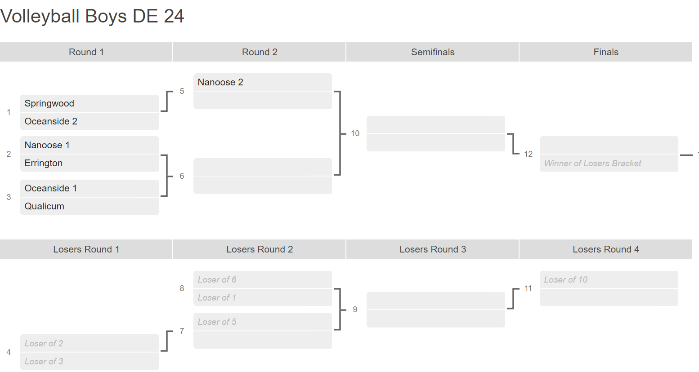

Wednesday (Girls League, part 1) ; Mar 13, 2024 @ EOES

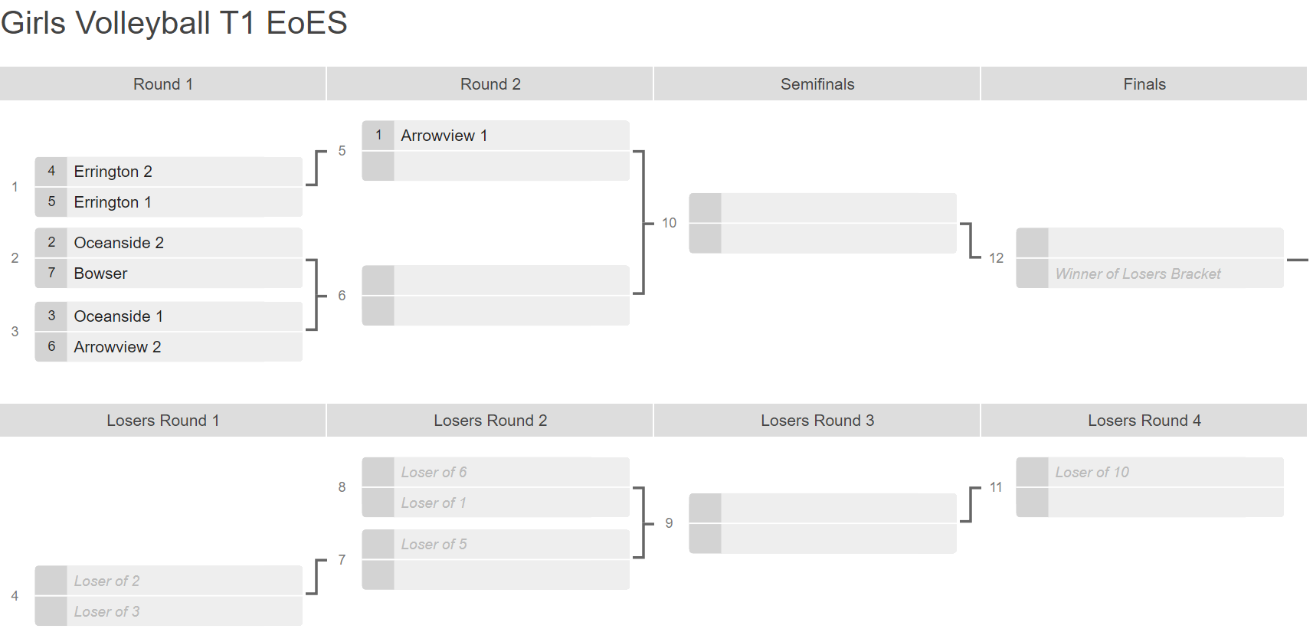
Thursday(Girls League, part 2 ) ; Mar 14, 2024 @ SES
