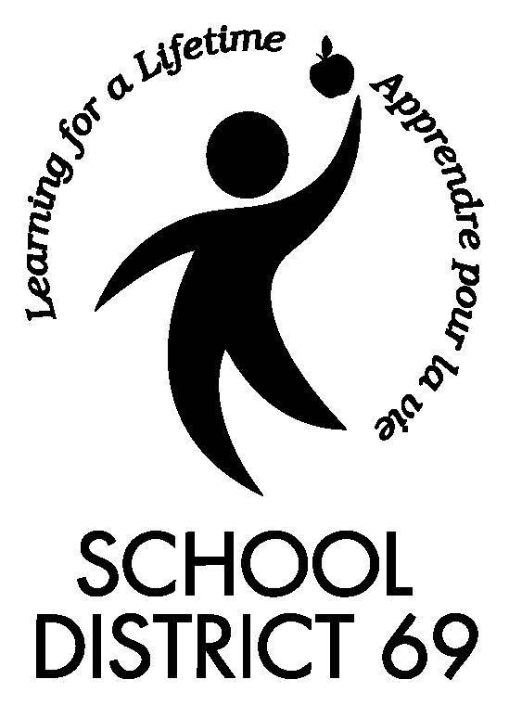 | Student use of Web-based (Cloud) Educational Tools:  Informed Parental Consent Process for Storage and Access of Information Both Inside and Outside of Canada

School District 69 is committed to promoting the safe and responsible use of web-based communication tools. We feel that the development of such skills in a supportive environment is the best way to prepare our students for the world they live in for today and tomorrow. We also believe strongly in the power of a positive digital footprint for all of our staff and students. A key part of this footprint is the use of Web-based publishing and storage of student work (storing “in the Cloud”). As a B.C. school district we are subject to the BC Freedom of Information and Protection of Privacy Act (FIPPA). Under this Act, we cannot upload and/or post to the internet, personal and identifiable information of a student (e.g., first name, last name, school, grade, teacher, class), including student work, without the written consent of the student’s parent or guardian.

The following sites have been identified by our school district as possible sites that may be used to support students in the construction of valuable web related skills as well as a positive digital footprint.

Animoto
Students could be using Animoto (http://animoto.com/legal/terms) to support the ability to create, store, and share videos from school and home as part of classroom assignments. Should parental permission not be granted, students will be able to use video editing software such as Windows Movie Maker, iMovie or PhotoStory as an alternative format assignment.

Diigo
Students could be using Diigo (https://www.diigo.com/terms) to collaboratively bookmark webpages. Should parental permission not be granted, students will use traditional web browser bookmarks.

Edmodo
Students could be using Edmodo (https://www.edmodo.com/corporate/terms-of-service) to provide a social learning platform for teachers, students, and parents. Should parental permission not be granted, students will use traditional school-home modes of communication.

EduBlogs
Students could be using EduBlogs (http://edublogs.org/terms-of-service/) to support the ability to create online journals and portfolios of learning from school and home as part of classroom assignments. Should parental permission not be granted, students will be able to use Microsoft Office as an alternative format assignment.

Flickr
Students could be using Flickr (http://info.yahoo.com/legal/us/yahoo/utos/utos-173.html) to store digital images. Should parental permission not be granted, students will be able to use the school network as an alternative format.

Glogster
Students could be using Glogster (http://www.glogster.com/terms-of-use) to support the ability to create, upload, store, and show presentations from school and home as part of classroom assignments. Should parental permission not be granted, students will be able to use Microsoft Office as an alternative format assignment.

Goodreads
Students could be using Goodreads (https://www.goodreads.com/about/terms) to share book reviews for independent reading. Should parental permission not be granted, students will be able to use Microsoft Office as an alternative format assignment.

Google
Students could be signing up for a Google account and using Google tools such as Chrome and Drive (http://www.google.com/intl/en/policies/terms/) to support the ability to create, upload, store, and retrieve web pages and documents from school and home as part of classroom assignments. Should parental permission not be granted, students will be able to use Microsoft Office as an alternative format assignment.

CONTINUED ON PAGE TWO
Kidblog
Students could be using Kidblog (http://kidblog.org/home/) to support the ability to create online journals and portfolios of learning from school and home as part of classroom assignments. Should parental permission not be granted, students will be able to use Microsoft Office as an alternative format assignment.
Narrable
Students could be using Narrable (https://narrable.com/terms_of_service) to create digital stories and commentaries using images, video and voice narratives. Should parental permission not be granted, students will be able to use PhotoStory as an alternative format.

PBWorks
Students could be using PBWorks (http://pbworks.com/terms-of-service) to support the ability to create collaborative online websites from school and home as part of classroom assignments. Any information students upload to the Wiki will be displayed with students’ usernames and emails. Should parental permission not be granted, students will be able to use Microsoft Office as an alternative format assignment.

Popplet
Students could be using Popplet (http://popplet.com/terms/) to visualize information and ideas in a mindmap format with the added ability to link to images, sound, video and more. Should parental permission not be granted, students will be able to use a paper-based mindmap as an alternative format.

Prezi
Students could be using Prezi (http://prezi.com/terms-of-use/) to support the ability to create, upload, store, and show presentations from school and home as part of classroom assignments. Should parental permission not be granted, students will be able to use Microsoft Powerpoint as an alternative format assignment.

SoundCloud
Students could be using SoundCloud (https://soundcloud.com/terms-of-use) to support the ability to create audio recordings from school and home as part of classroom assignments. Should parental permission not be granted, students will use Audacity as an alternative format assignment.

Weebly
Students could be using Weebly (http://www.weebly.com/terms-of-service/) to support the ability to create online websites and portfolios of learning from school and home as part of classroom assignments. Should parental permission not be granted, students will be able to use Microsoft Office as an alternative format assignment.

WikiSpaces
Students could be using WikiSpaces (http://www.wikispaces.com/Terms) to support the ability to create collaborative online websites from school and home as part of classroom assignments. Any information students upload to the Wiki will be displayed with students’ usernames and emails. Should parental permission not be granted, students will be able to use Microsoft Office as an alternative format assignment.

YouTube
Students could be using YouTube (http://www.youtube.com/t/terms) to support the ability to upload, store, and share videos from school and home as part of classroom assignments. Should parental permission not be granted, students will post videos to the school network as an alternative format assignment.

For each of these sites, students will need to sign up for their own (free) account to access the service using their personal or school district email address. Note that each of these sites is an online service located outside of Canada and is within the jurisdiction of the United States of America, and thus is subject to American information laws. Students should avoid storing documents and other data that includes information that could be used to identify themselves or other persons. We do believe in the power of a positive digital footprint; however, students will be instructed how to minimize their web presence while their work is in progress by limiting the use of student last names; using “search engine optimizers” to block common search engines from finding student work, and using high privacy settings on each site.

Please fill out and return if you give permission for your child to participate in the web-based (cloud) sites and storage as described above. Please return to your child’s teacher by Friday, Oct. 17th. If you have any questions or concerns, please feel free to contact Mrs, Gunn, NBES Principal at tgunn@sd69.bc.ca or 250-468-7414.

Student use of Web-based (Cloud) Educational Tools:
Informed Parental Consent Process for Storage and Access of Information Both Inside and Outside of Canada

Student’s Name: (Last) (First) (please print)

School:

I understand that the information my child may create and store, will be stored in or accessed from a location outside of Canada and I hereby consent, on behalf of me and my child, to my child’s information identified above being stored in, or accessed from, a location outside of Canada. I also understand that this permission will be in effect immediately and will expire on Sept. 30, 2015. I also understand that I may withdraw this consent at any time with written notice to the principal.

Date:

Parent/Guardian Name: (Last)

(please print)
(First)

Parent/Guardian* Signature:

Parent/Guardian Phone Number: Email:

To Be Completed By Secondary Students Only:

I am aware of my parent’s wishes as expressed above and understand that I am primarily responsible for the protection of my own privacy at school and at school activities and will take appropriate to ensure I have a positive digital footprint.

Student Signature: _________________________________________________

This section is to help guide you if you have additional sites you wish to add.

Informed Parental Consent must include:

Once the educator has settled on a location for posting student exemplars, the educator must provide written notice to the parent/guardian that would outline:
- Reason for posting content or using the site/service
- Specific site/service to be used for posting content
- Types of content to be posted
- Whether students would be required to establish an account on the site/service
- Identifiable privacy risks for establishing an account and/or posting data to the site/service
- The educator’s risk management strategies for using the site/service
- The educator’s alternative activity if permission is denied

