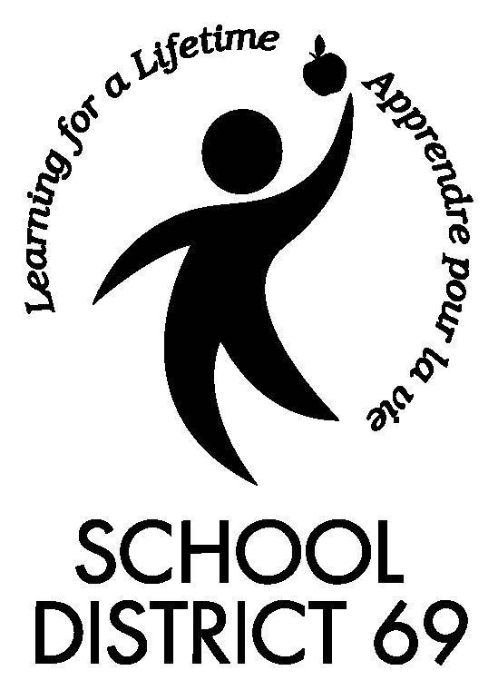 | School District 69 – Qualicum  Student FOIPPA / Personal Information Consent Form  2014-2015

Parents* and, if applicable, secondary school students: Please read the notice below and complete and sign the form on the back of this page and return it to your child’s school.

Freedom of Information & Protection of Privacy (FOIPPA)
Schools and school districts are authorized to collect, use, and share student personal information that is directly related to and necessary for their educational functions. For other school or education related purposes, parental or student consent is required.

In accordance with the BC Freedom of Information and Protection of Privacy Act, the Board of Education of School District 69 (Qualicum) is seeking your consent to collect, keep, use and share photographs, videos, images and/or names of students in a variety of publications and on the school or School District’s website(s) for education related purposes, such as recognizing and encouraging student achievement, building the school community, and informing others about school and District programs and activities.

For example, student names, and/or images may be used or shared in:

• School and District communications, such as newsletters, news releases, brochures and reports in limited or public circulation;
• School and District websites, social media sites (e.g. Facebook), and online video (e.g. YouTube) with limited or public access;
• Videos, CDs, DVDs designed for educational use only.

Personal Information Protection Act (PIPA)
Additionally, outside media (including radio, television, newspapers, and other print and online media) are sometimes permitted or invited to come to the school or to school activities and allowed to take photos or video, or conduct interviews with students for the purposes of promoting public understanding of school programs, building public support for public education, and encouraging student achievement.

Parents and guardians should be aware that when outside media are permitted access to schools for general journalistic purposes, the consent requirements of the Freedom of Information and Protection of Privacy Act do not apply because the School District is not collecting, using or disclosing personal information. Media organizations are subject to the Personal Information Protection Act (PIPA) however, under PIPA, the media organization does not require consent if its purposes are purely journalistic.

If you DO NOT want your child to be involved in such activities, in addition to completing this form, you need to:

• Tell your child to avoid these situations.
• Tell your child’s teacher of your wishes.

When possible, the school or School District will provide advance notice of when outside media presence is scheduled at the school.

Note: School and School District staff cannot control news media access, photos/videos taken by the media or others in public locations (such as field trips, or off school grounds) or school events open to the public, such as sports events, student performances, school board meetings, etc.

Having read this notice, please complete and sign the form on the back of this page and return it to your child’s school. Consents are effective immediately and last until September 30 of the next school year.

School District 69 – Qualicum Page 1 of 2

School District 69 – Qualicum
Student FOIPPA / Personal Information Consent Form
2014-2015

Student’s Name: (Last) (First) (please print)

School:

Please check A OR B (not both):

A. I GIVE MY CONSENT for the school or School District 69 (Qualicum) to collect, keep, use and share my child’s name and/or image for purposes consistent with the above and for my child to participate in activities to which the outside media may be invited. I understand that images and information posted on the Internet may be stored and accessed outside of Canada.

This consent may be withdrawn at any time in writing but withdrawal of consent does not require the school or District to take any steps to withdraw from publication any previously published material. Unless withdrawn, this consent is effective immediately and lasts until September 30 of the next school year.

B. I DO NOT CONSENT to the use and disclosure of my child’s name and/or image for the above purposes and request that the School District and its staff take all reasonable steps to avoid having my child’s image or name collected or published by outside media when they are present in school or at school activities at the invitation of the school or School District for this school year.

Date:

*For parents who have court orders describing their parental rights, this form should be signed by the parent who has the right to exercise the student’s privacy protection rights.

Parent/Guardian Name: (Last)

(please print)
(First)

Parent/Guardian* Signature:

Parent/Guardian Phone Number:
Email:

To Be Completed By Secondary School Students Only:

I am aware of my parent’s wishes as expressed above and understand that I am primarily responsible for the protection of my own privacy at school and at school activities and will take appropriate steps to do so.

Student Signature:

School District 69 - Qualicum Page 2 of 2

