Home Support - Guidelines for Internet Safety

As your child may spend an increased amount of time online while learning at home, it is important to maintain digital and online safety, health, and security. While students are learning at school, the Qualicum School District applies filtering services and firewalls to protect web content. At home, you may not have these same protections. Here are some guidelines for you to consider in maintaining internet safety for your child.

Online sources: The online resources, tools, and activities provided to you by your child’s teacher, the school, and the Ministry of Education are trusted sources. (Example: The Ministry of Education has provided our district with access to the province’s licensed Zoom platform, and some students may be invited to interact and collaborate with their teacher using this secured version.) Please note that other online sources may not be trusted and will require your scrutiny.

Safe practices:
- Inform your child to keep any passwords used private. They should not be shared outside of immediate family.
- Explain to your child that they should never share any personal information online (i.e. their name, age, location, parent’s name, gender, school, siblings).
- Place home devices that your child will be using in a high traffic area in the home, such as at the kitchen table and not your child’s bedroom, to facilitate supervision of their online activity and interactions.

Wi-Fi Security: Ensure that your Wi-Fi is secured and protected with the latest updates. Take extra precautions against malicious activity like suspicious emails and online requests for private information, passwords, or offers of free software. The Canadian Internet Registration Authority (CIRA) has more information on how to stay protected.

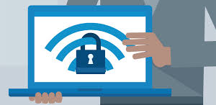

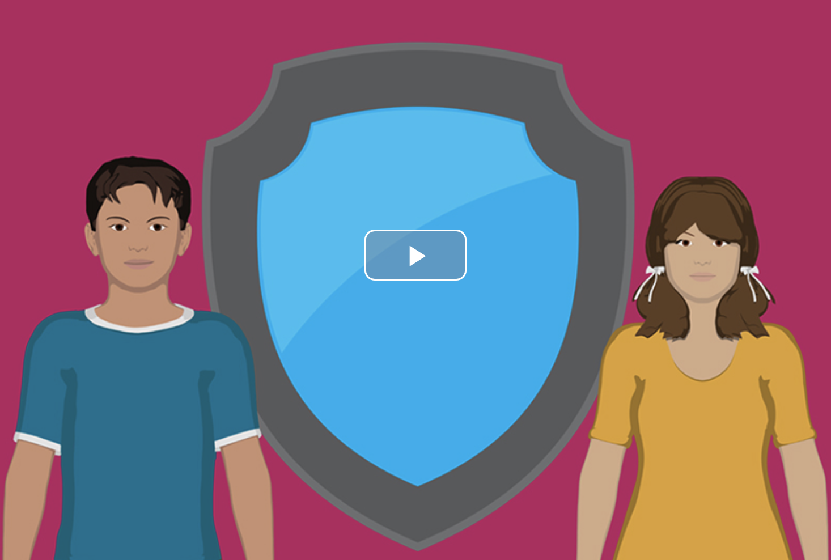

More parent information:

- The Ministry of Education Online Safety page includes ‘Tips for Parents’, and information about other topics, such as ‘Cyberbullying’, ‘Managing Screen Time’ and more.
- Watch the 5-minute video Protecting Your Kids Online.

Note: Learning at home does not require students to spend hours and hours online. If unsure about the amount of technology use required, please connect with your child’s teacher with your questions. Also, if your child is unable to use or has limited access to devices for online learning at home, please inform your child’s teacher to determine alternative options.

