Ballenas Secondary School
Grad Transition Plan Assignment
Student Name: Click here to enter text.
- Describe one of your experiences during high school that you are most proud of and state why.
Click here to enter text.

- Describe your top three characteristics. Is there a characteristic that you would like to improve on?
Click here to enter text.

- What advice would you give to a student who is entering high school?

Click here to enter text.

- What short term goals do you have for next year?
Click here to enter text.

- In regards to long term goals, where do you hope to be in five years? Describe where you hope to be working or what training you may be pursuing.
Click here to enter text.

- Name the steps you will have to take to help achieve your short and long term goals.
Click here to enter text.

- Describe how your personality, characteristics and past achievements match your future plans.

Click here to enter text.

- What is your educational or personal backup plan in case your initial plans don’t work out?

Click here to enter text.

BUDGET

Building a Budget is the act of combining your income and expenses so that you can decide how much money you are going to spend on one item, how much on another, and so on-before you actually spend the money. Creating a budget is a realistic financial plan, which you put together, based on your income, expenses, and goals.

Regardless if your after grad plans are to go to post-secondary, trades school, travel or to work, you are to complete the “Post Secondary Budget” on the next page.
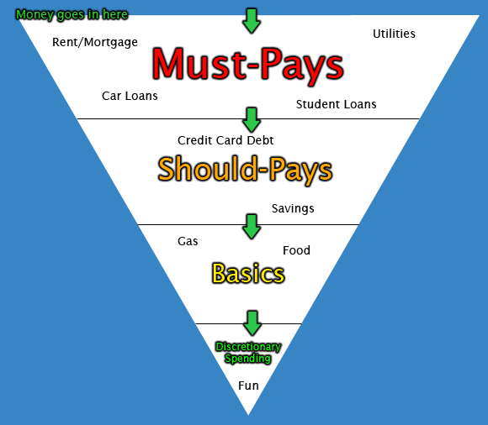
Transportation

POST SECONDARY BUDGET
Income | Monthly Budget | Yearly Budget
From Jobs | Click here to enter text. | Click here to enter text.
From Parents/Guardian/Family | Click here to enter text. | Click here to enter text.
From Student Loans | Click here to enter text. | Click here to enter text.
From Scholarships/Bursaries | Click here to enter text. | Click here to enter text.
Miscellaneous Income | Click here to enter text. | Click here to enter text.
Income Subtotal | Click here to enter text. | Click here to enter text.
Expenses
Rent or Room & Board | Click here to enter text. | Click here to enter text.
Utilities | Click here to enter text. | Click here to enter text.
Phone | Click here to enter text. | Click here to enter text.
Groceries | Click here to enter text. | Click here to enter text.
Car Payment/Insurance | Click here to enter text. | Click here to enter text.
Car Operating Expenses | Click here to enter text. | Click here to enter text.
Other Transportation (ie bus) | Click here to enter text. | Click here to enter text.
Insurance | Click here to enter text. | Click here to enter text.
Entertainment | Click here to enter text. | Click here to enter text.
Eating Out/Vending | Click here to enter text. | Click here to enter text.
Tuition | Click here to enter text. | Click here to enter text.
Books | Click here to enter text. | Click here to enter text.
School Fees | Click here to enter text. | Click here to enter text.
Computer Expense | Click here to enter text. | Click here to enter text.
Miscellaneous Expense | Click here to enter text. | Click here to enter text.
Expenses Subtotal | Click here to enter text. | Click here to enter text.
Net Income  (Income less Expenses) | Click here to enter text. | Click here to enter text.

The following links may help with your budgeting:
http://www.viu.ca/financialaid/cost.asp
http://www.uvic.ca/future-students/undergraduate/tuition-scholarships/
http://www.costofliving.welcomebc.ca/
*please consult family for costs for running your current home

Now that you have completed your budget, is there anything that might prevent you from achieving your plans? (If your net income is in the negative, you need to rethink your budget)

Click here to enter text.
Post-Secondary Training Plan
Every student is to complete this section as if you intend to go on to some sort of post-secondary education. If you have no post-secondary plans, select Vancouver Island University or North Island College and find a program that may be of interest to you. To help you with your research use the following websites www.careercruising.com/login/SD69
(Username: student number, Password: date of birth (MMDDYYYY)

Select one institution/school where you plan to train/study and complete the following:

Name of Institution or School: Click here to enter text.
Location: Click here to enter text.
Program Name: Click here to enter text.
Entrance requirements: Click here to enter text.
What is the length of the program? Click here to enter text.
When is/was the deadline for application? Click here to enter text.
Is there a wait list? No How long is it? Click here to enter text.
What type of living accommodation do you plan to have?
☐ Residence ☐ Sharing a House
☐ Apartment ☐ Living with Family
☐Other: Click here to enter text.
Cost of the Program: Click here to enter text.
How do you plan to pay for the program? Family, my savings, and scholarships
What factors influenced your decision on this post-secondary institution?
Click here to enter text.

Having completed your Graduation Transition Plan, describe how you feel about your plans. Are you excited? Are you nervous? What worries you about the future? What do you look forward to? Explain.
Click here to enter text.

This year you will be presenting your transition plan to your LINK on Wednesday, April 26th
during D block. You may want to print off a copy of this document to have on hand to refer to during your presentation
Guiding Questions for Grad Transitions

- Tell us about your fondest memory of high school.
Click here to enter text.

- What was your greatest source of stress during your high school years? How did you manage your stress?
Click here to enter text.

- How have you changed as a person from when you entered high school to now?
Click here to enter text.

- If you had to do it all over again, what would you do differently?
Click here to enter text.

- How did you figure out what you wanted to do after high school?
Click here to enter text.

- What challenges do you face in financing your transition plan? What surprised you?
Click here to enter text.

- Do you have any other advice that you would like to share with us?
Click here to enter text.

