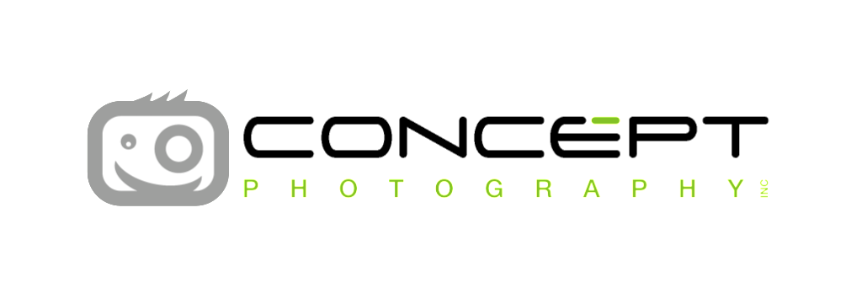
Photo Day is: September 13th
Retake Day is: October 17th

A few things to remember.
- You will receive an online code to access your portrait gallery. You can expect to see your child's online code come home 48-72 hours after photo day.
- If you do not receive a code after 72 hours please contact us immediately.
- Visit myportraits.ca to see our FAQ's and tips on how to prepare for an awesome photo day!

NEW This Year.
- Your childs online code will be their student ID number
- Get exactly what you want with our Build Your Own portrait packages
- Choose from new background options
- New product options
- Get your portraits quicker with Earlybird quick ship for only $5

Order By:
Please allow 3-4 weeks after this date for your child's portraits to be delivered to the school
IMPORTANT: Any orders placed after this date will be subject to an $8 shipping fee and will be delivered directly to your home.
Visit myportraits.ca
We’re here to help.
Please contact us directly with any questions.
lance@conceptphoto.ca 250.741.4209

